FLowchart and Complexity for N Queens’ solution by Vector
- Flowchart.
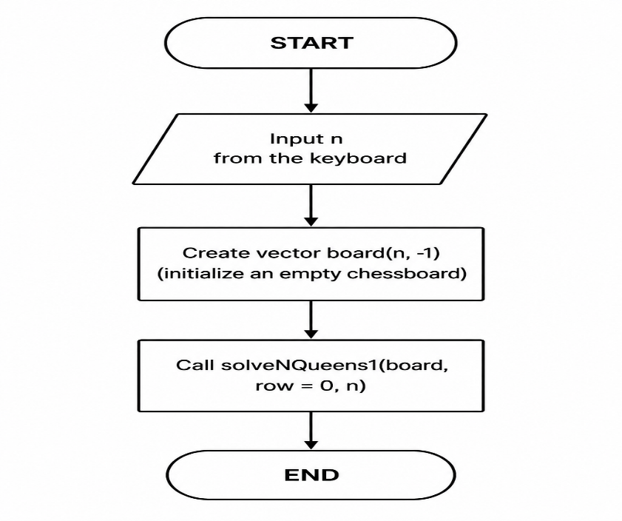
- Complexity.
- Time complexity :
For each row the algorithm may try up to n different columns. After placing one queen, the number of available positions in the next rows decreases. The total number of possible arrangements grows :
n×(n−1)×(n−2)×⋯×1=n!
The function isSafe() checks previously placed queens to determine whether the current position is valid. This checking process can take up to n operations. Therefore, the overall time complexity of the algorithm is:
O(n!⋅n)
- Space complexity :
- A vector board with n elements to store the positions of queens,
- The recursion stack generated by the backtracking process, whose maximum depth is n.
As a result, the total memory usage grows linearly with n:
O(n)

